Assignment 2.1

Task 1:

Check whether /user/acadgild directory exists or not in the HDFS.





The directory exists as status of test command returned 0

If it doesn't exist, then create this.

Create a directory /user/acadgild/hadoop.

Create a file in HDFS under directory /user/acadgild/hadoop, with name word-count.txt.



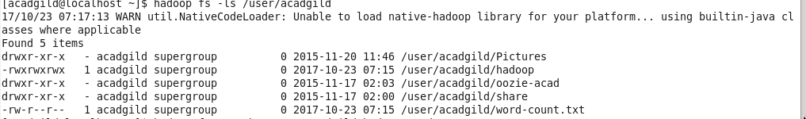

Whatever we type on screen should get appended to the file.



Try to type (on screen) few lines from any online article or textbook.